Everything about Australia

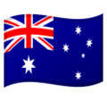
Task IV. Australian People
- Interesting things about Australian society.
  - What are Australian people called?
  - What are the indigenous Australian people called?
  - When did the British colonisers arrive to Australia?
  - What’s Australia’s population today?
  - What percentage of it is Australian born?

- Name six famous people from Australia – a man and a woman in each category.
  - two sportspeople
  - two arts people (music, film, literature, etc...)
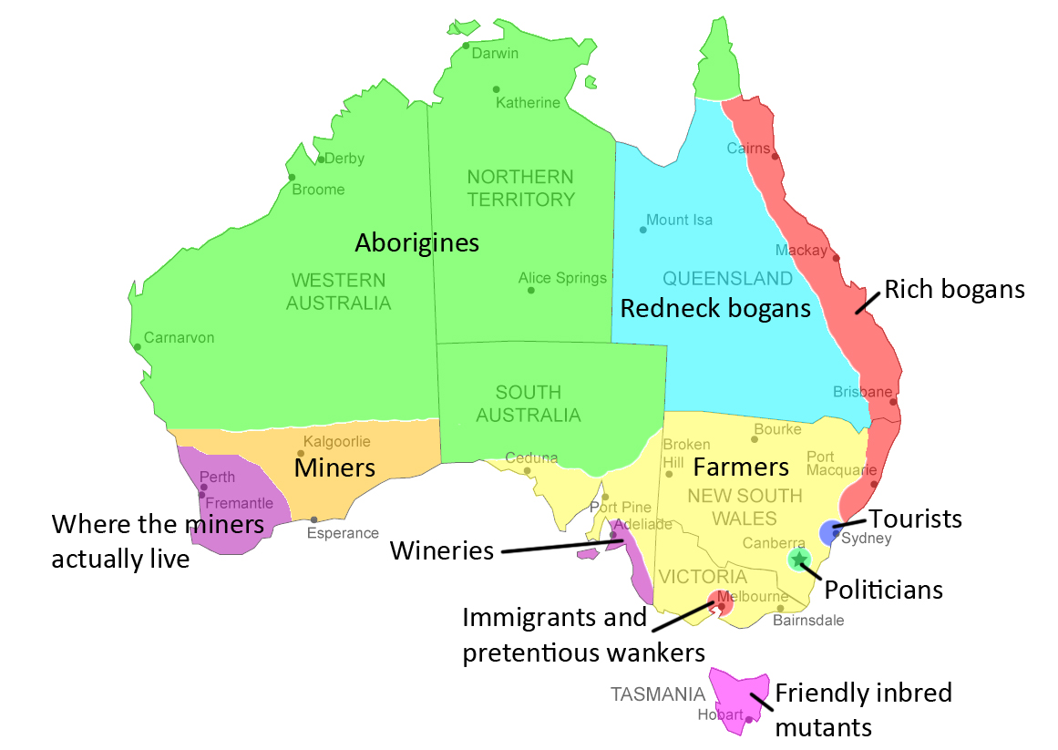
  - two people in any other fields (science, society, politics, etc...)

- Who is/are the Australian that...?
  - won the Australian of the Year Award in 2009?
  - won the Olympic Women’s 100-metre freestyle three times in a row?
  - was awarded an Order of the British Empire for his inventions in 1944?
  - won the Nobel Prize in Physiology or Medicine in 2005?
  - has won four Academy Awards, more than any of her fellow citizens?

The deadline is Thursday 12 am.

Send it to the following email address: maraz_aliz@yahoo.com

