Everything about Australia

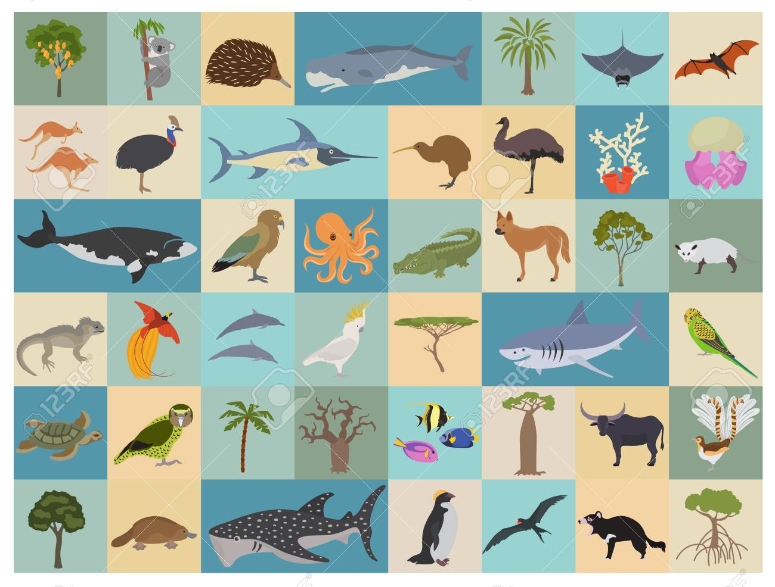
Task III. Australian Fauna
- Name six emblematic animals of Australia.
Which two of them are on the coat of arms of Australia?

- What animals do these Australian terms refer to?
  - settler’s clock
  - ocky
  - woofer
  - underground mutton
  - freshie
  - chook
  - boomer
  - joey
  - jumbuck

bonus: What’s the name of the mythical outback creature known to inhabit waterholes and billabongs?

- Facts about the Great Barrier Reef.
  - Where is it situated exactly?
  - How long is it?
  - What kind of marine creatures does it provide home for? Name at least six different species.
  - List three types of danger that destruct the Reef these days.

The deadline is Wednesday 12 am.

Send it to the following email address: maraz_aliz@yahoo.com

